Modop Vega tool (English Version)
Last update : 30/12/25
Created by : Nathan BODIN
Table of contents
Contacts 1
Importation du visuel 2
Quick start 6
Les colonnes autorisées (et à quoi servent elles) 14
Colonnes de la Hiérarchie (Obligatoire) 15
Colonnes de dates (Obligatoire) 15
Les jalons (Colonne « Milestone ») 15
La forme des jalons (Colonne « Shape ») 15
La taille des jalons (colonne « ShapeSize ») 16
La Légende (colonne « Legend ») 17
La couleure (colonne « Color ») 17
La hauteur ds rectangles (Colonne « Size ») 18
Les étiquettes dans les rectangles (Colonne « Label ») 18
Paramétrage du visuel 19
La matrice (Superposition/filante) des rectangles 19
Paramétrage de la matrice des Jalons 21
Paramétrage de la taille des formes 22
Les paramètres du visuel 23
Remerciements 24

Contacts
If you have any questions, you can contact me here :
Email : nathanbodin01@gmail.com
Linkedin : Nathan Bodin
Instagram : @nathanbod1

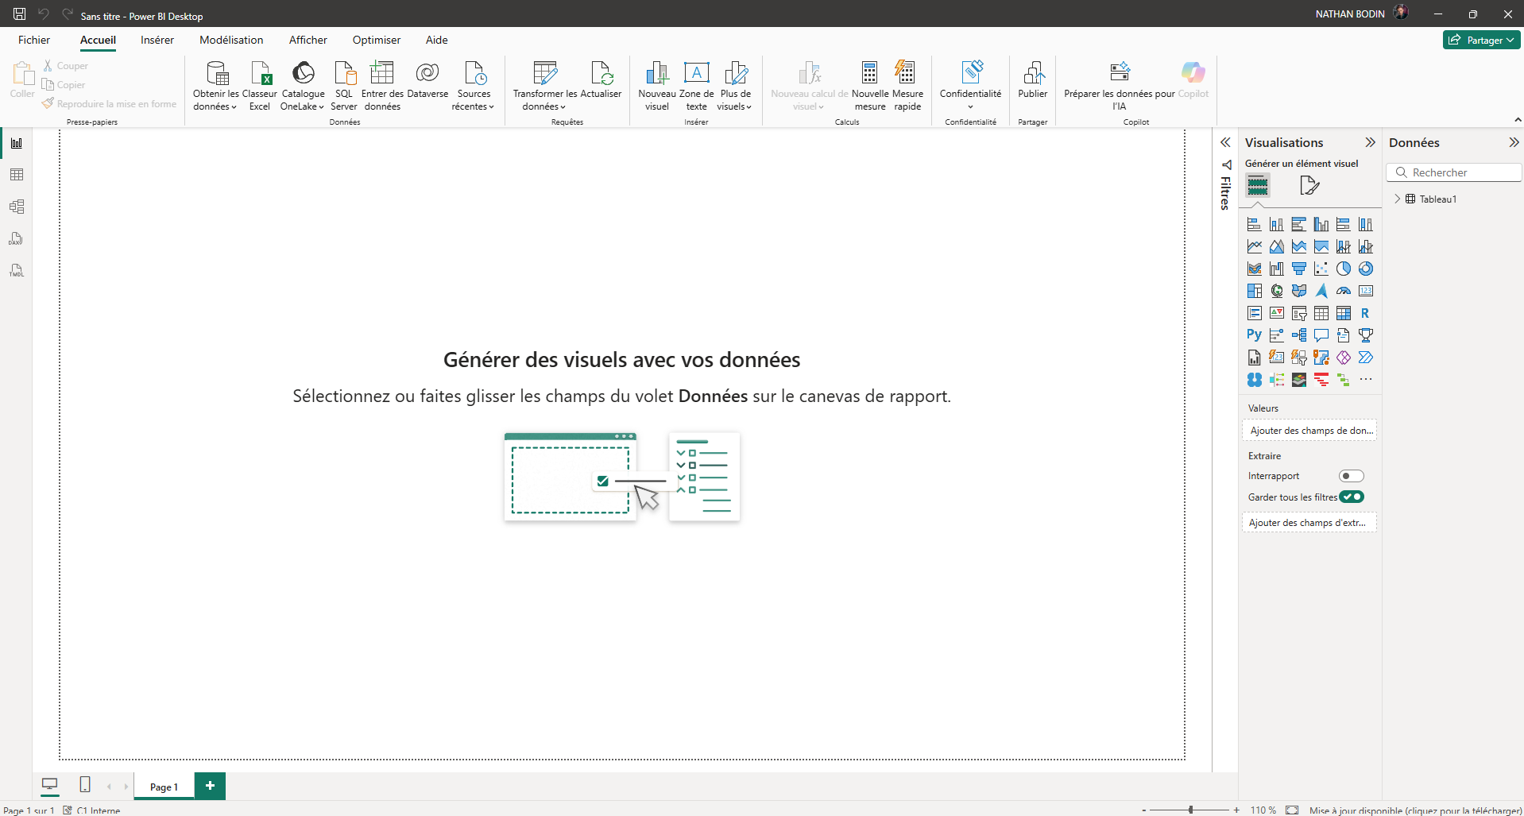
Importing the visual
1

Here's what you see when you arrive at PowerBI.
- Click on the « … » (1)
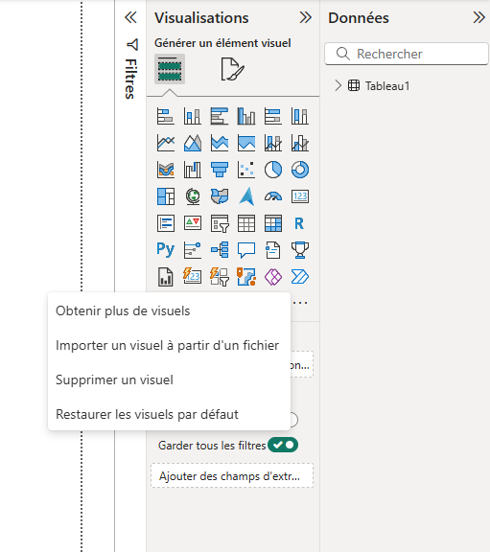
2

- Then click on « Obtenir plus de visuels » or « Get more visuals » (2)
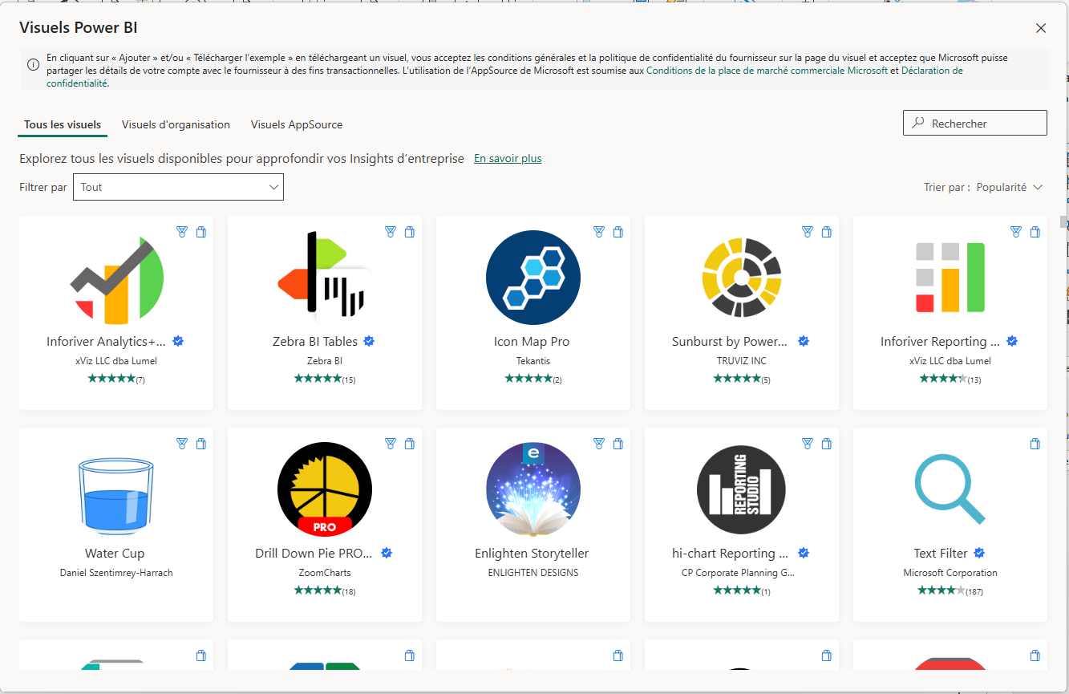
3
You have arrived at this page.
- In the search bar (3) type “Deneb” (this is the support for the solution).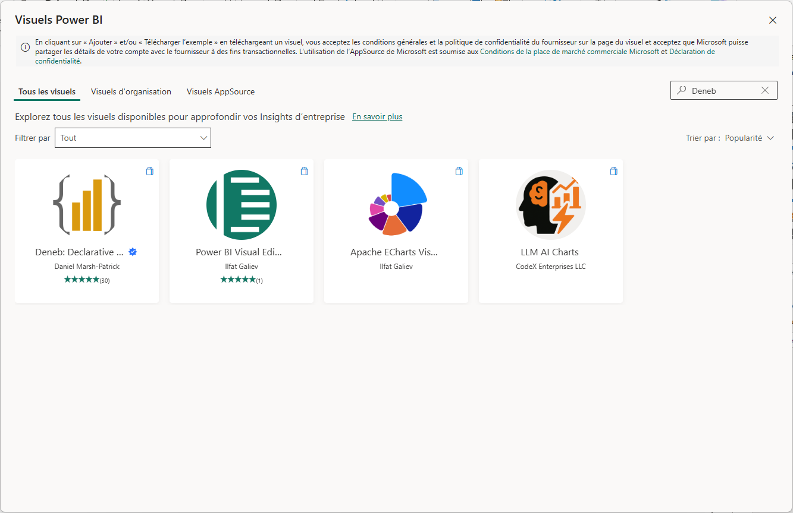
4
- Then click on the image “Deneb: Declarative…” (4)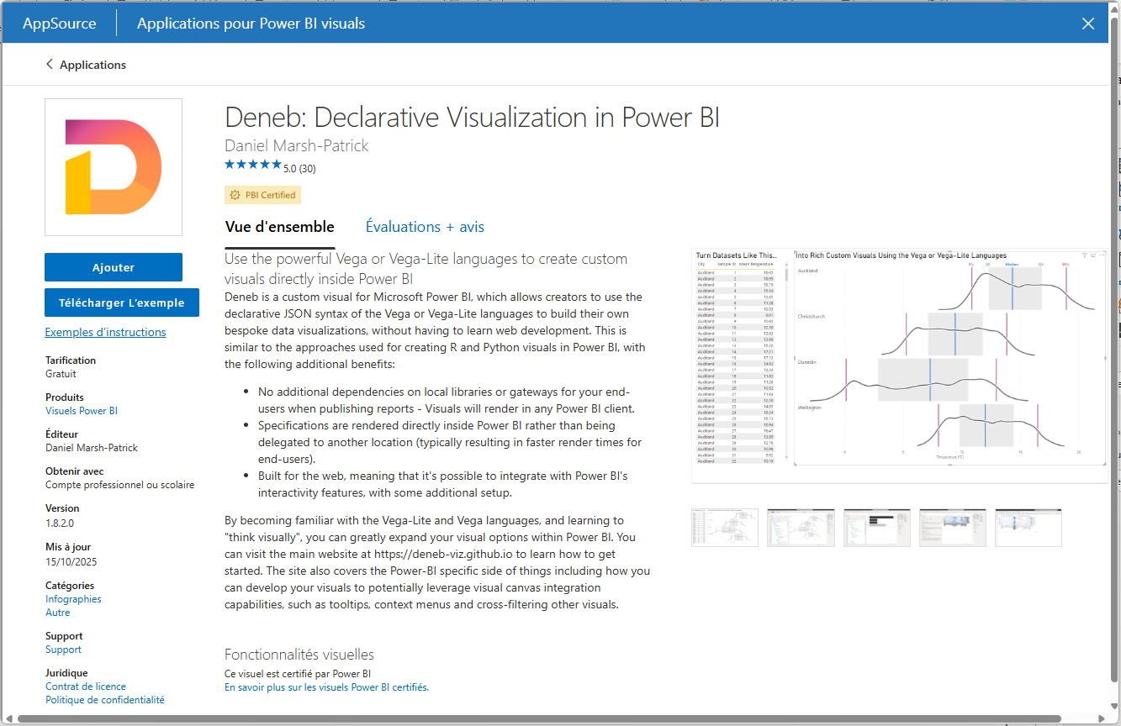
5
- Click on « Ajouter » or « Add » (5)

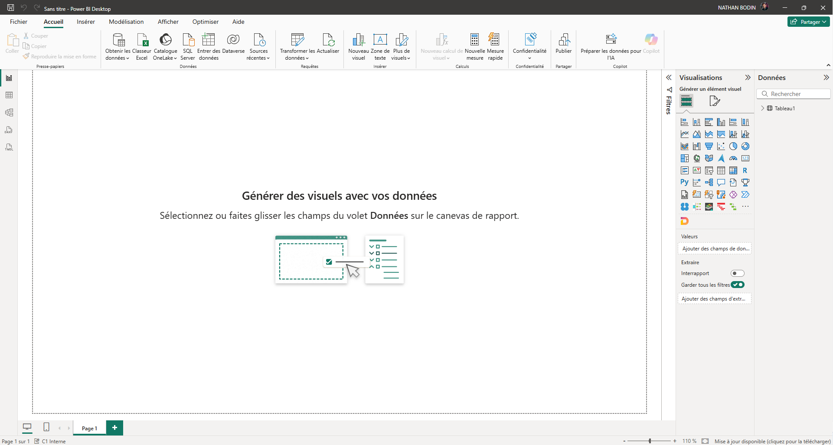
6
A new image has just appeared (6)
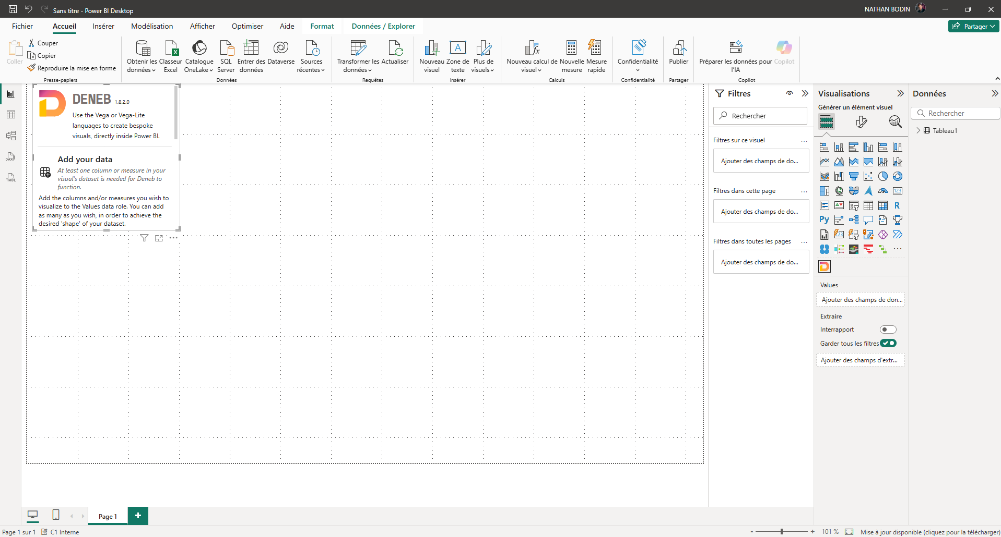
- Click on this new visual (6)
7

A new window has just appeared (7). You can enlarge it if you wish. You have just imported the Deneb visual which will support the visualization solution.

Quick start
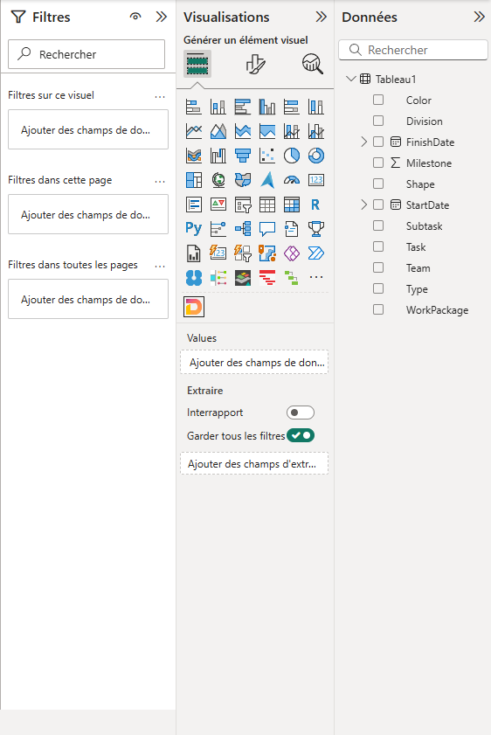

On the right side of Power BI you can see the columns of your data.
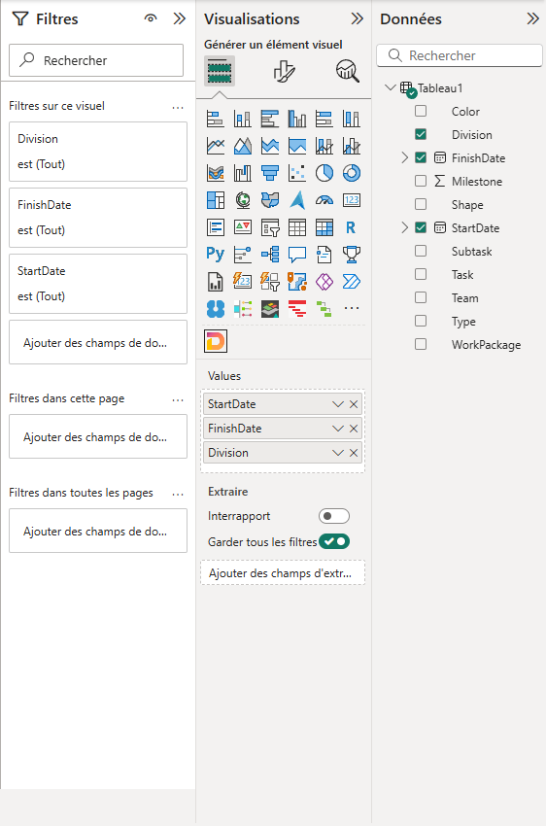

- Select the data you want to view. These column names will also appear in "Values"; if so, then everything is fine.
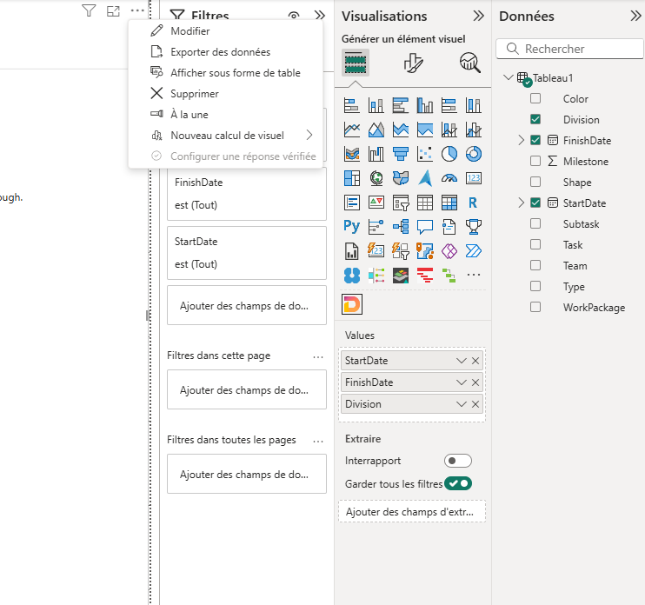
11

- Once you have selected your columns, click on the "…" (11) and then on "Edit" (11).

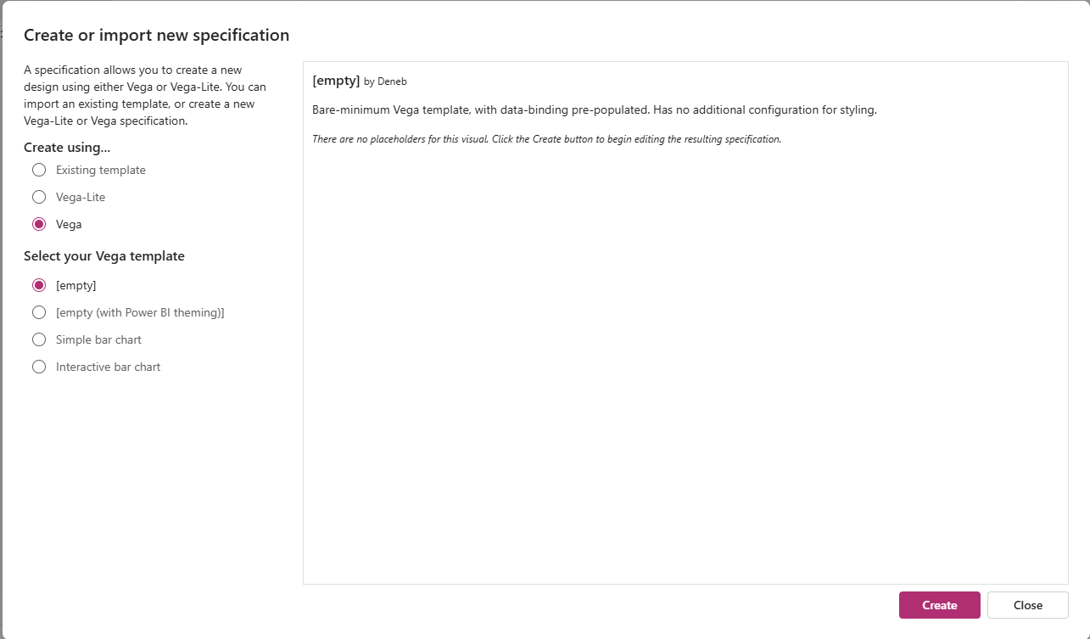
- A page will appear. Click on "Vega" then slightly below "Empty" then "create".
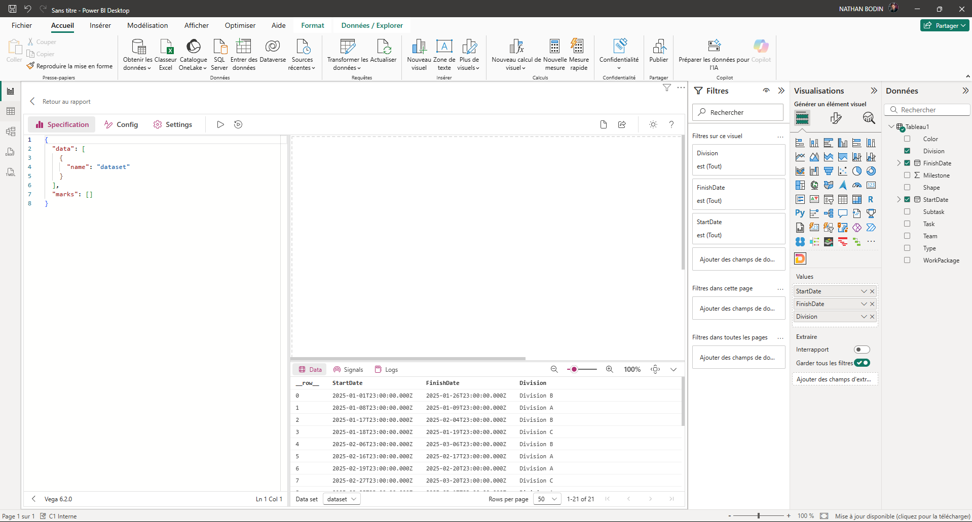
13
12
Once this is done, this window will open. On the left (12) you will find the code section, the data section (13) below the visual, and the visual section in the center.
- Delete the few lines of code in (12) and then copy and paste the solution code which is here : https://github.com/npaatrhiasn/Gantt-on-steroids/blob/main/codeBI.json
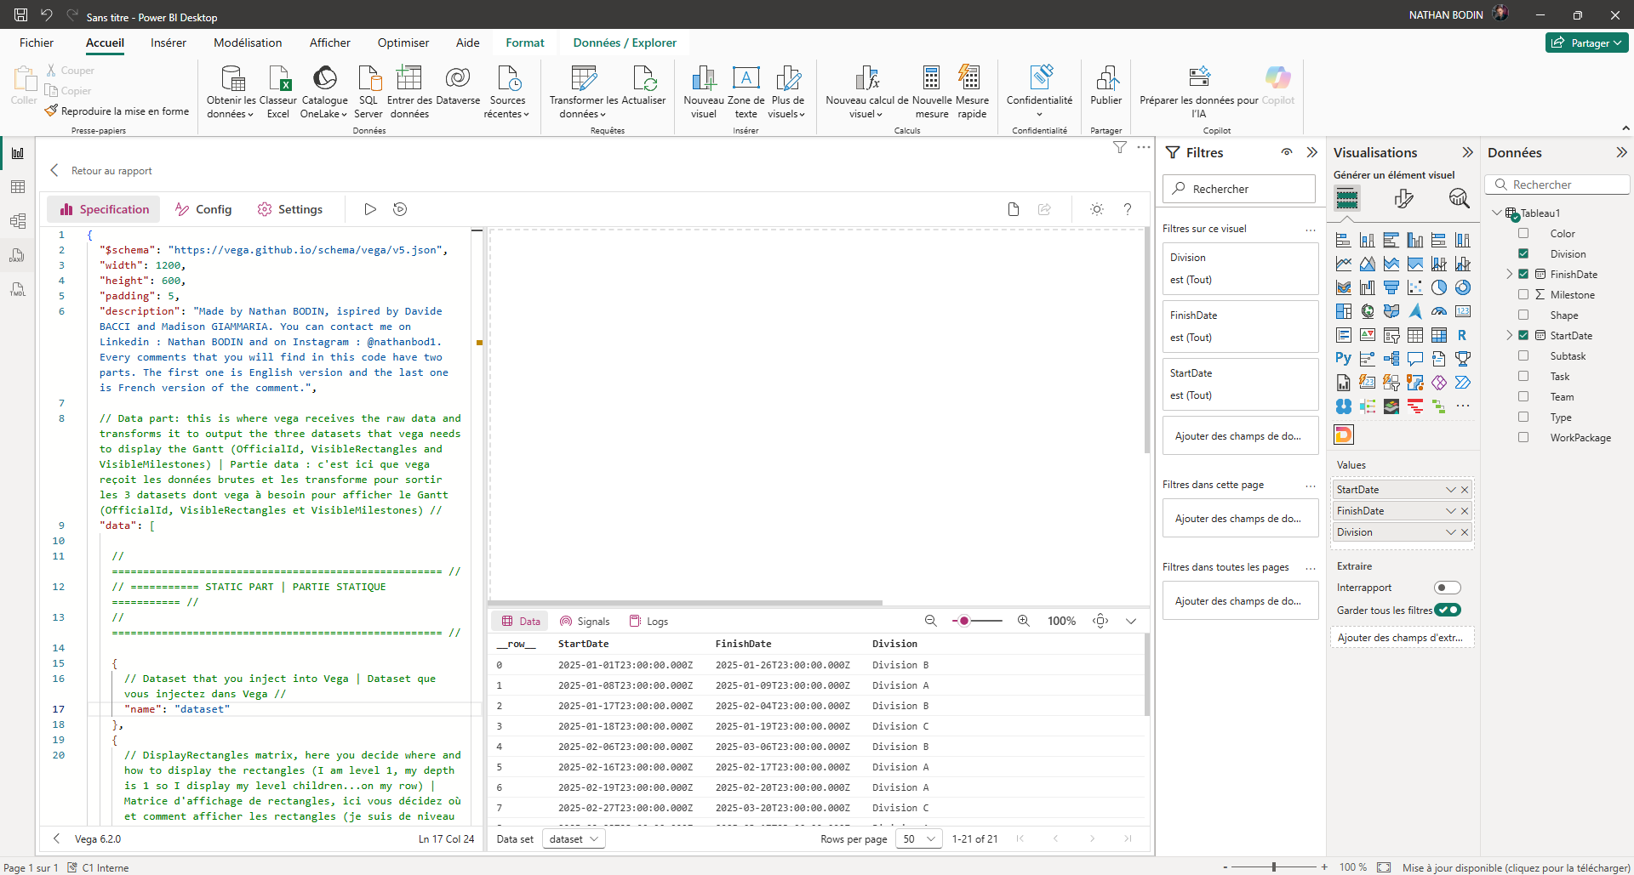
14

The code is now in the visual
- Click on « Config » (14)
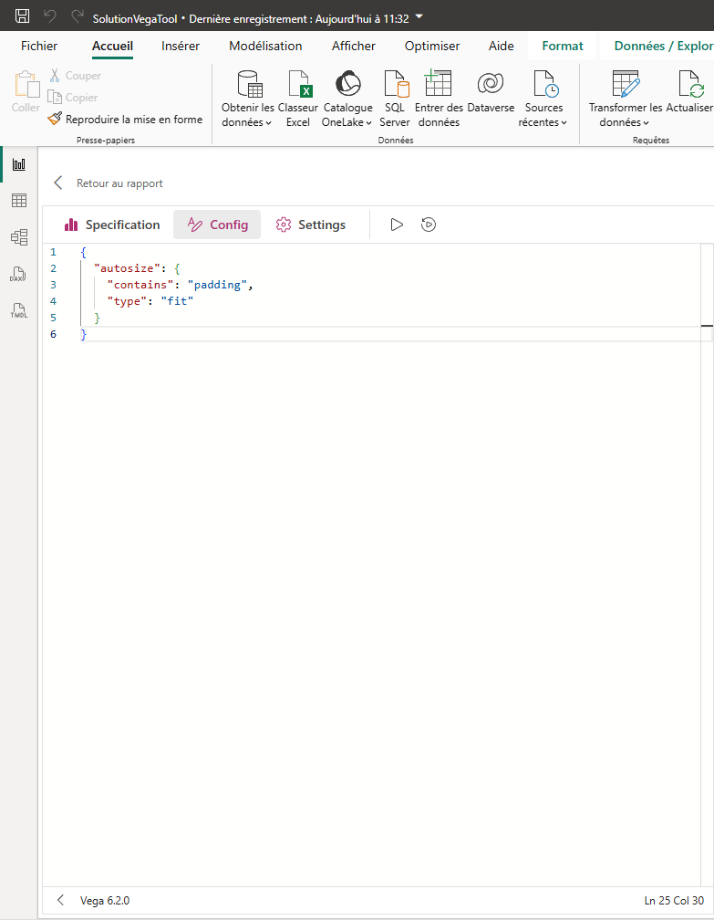

- Delete the code that is there
15

- Return to "Specification"
- Then press "run" (15)
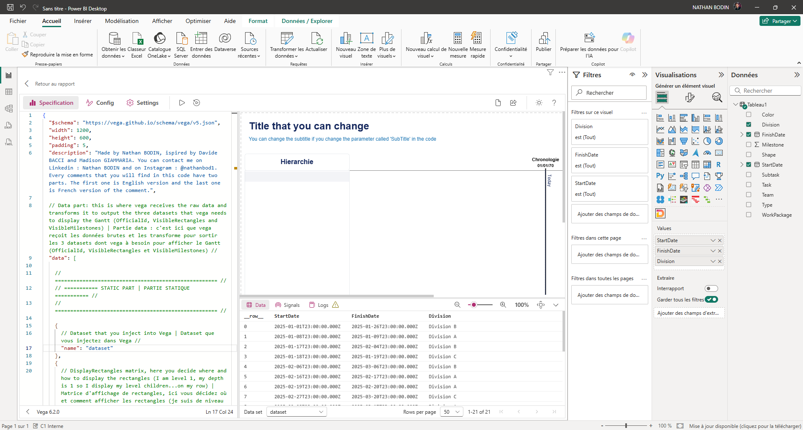

Nothing is displayed at the moment and that's normal because we haven't done the mapping (renaming the column so that the visualization solution understands what you want).
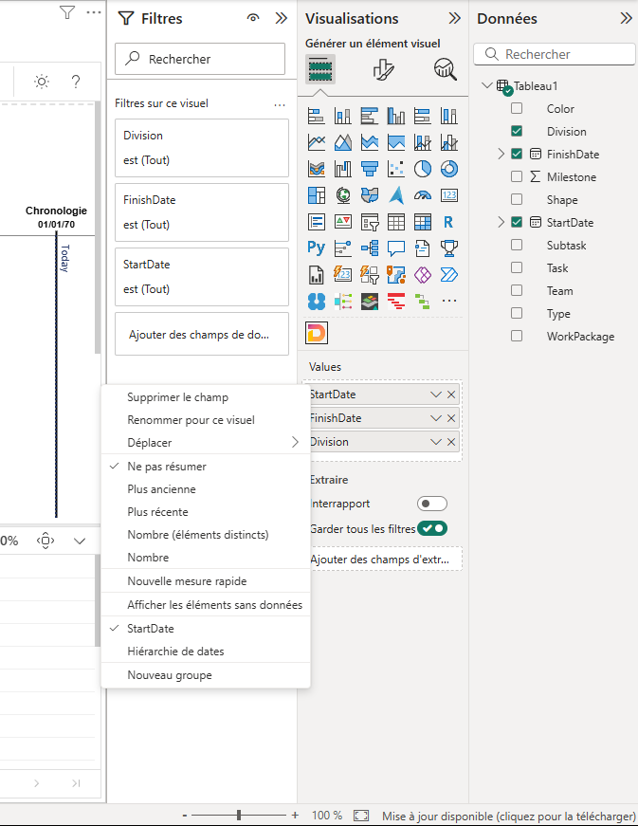
16

To rename the columns:
- Right-click on one of your columns in the "Values" section (16)
- Then « Renommer pour ce visuel » or « rename for this visual » (16)
- Rename your start date column to "Start"
- Rename your end date column to "End"
- Rename your first content column to "Category"
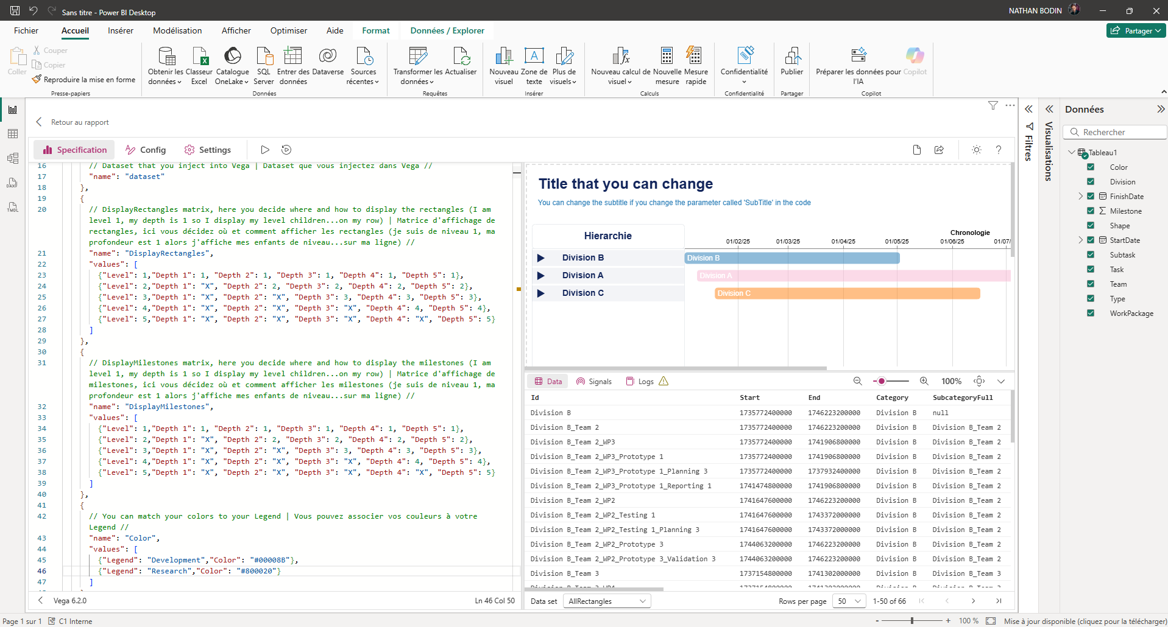
17

- Then, go into the code, go to line 21. Here is the matrix which is used to control the behavior of the rectangles (17).
- On line 23, after "Depth 1:" replace the number with 1
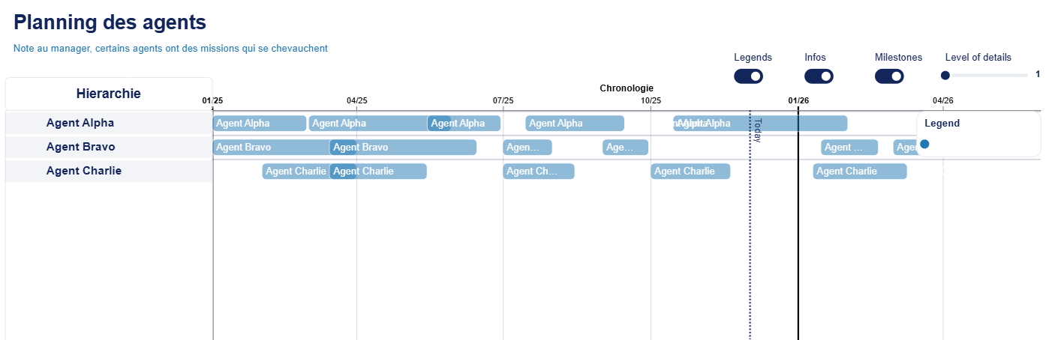
- Click on « run »

Here's what you should observe. (With your data, the visualization will not be the same as the one shown in the example).

The allowed columns (and what they are used for)
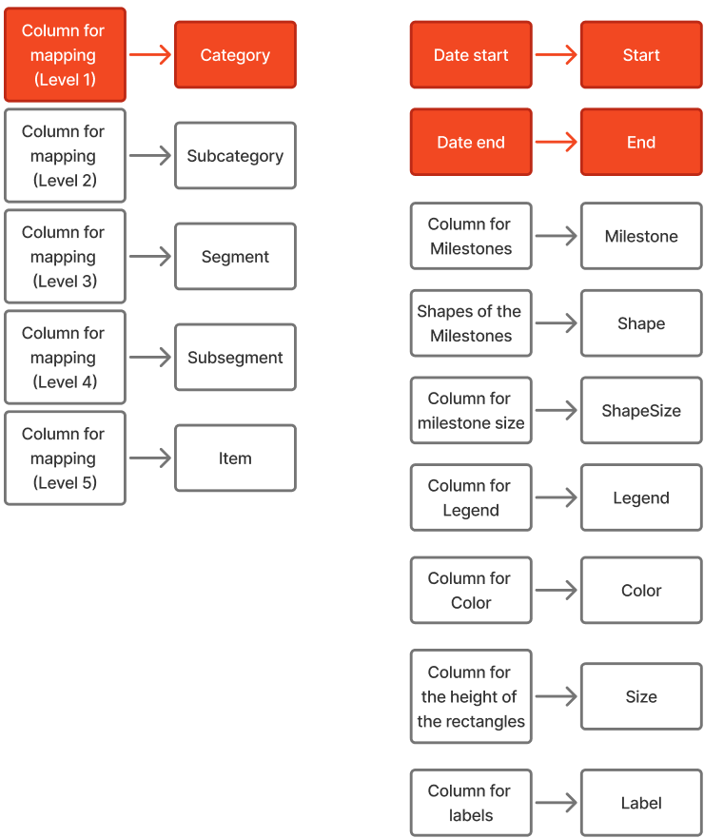
The elements in red are mandatory (these are the 3 columns I put in the example above).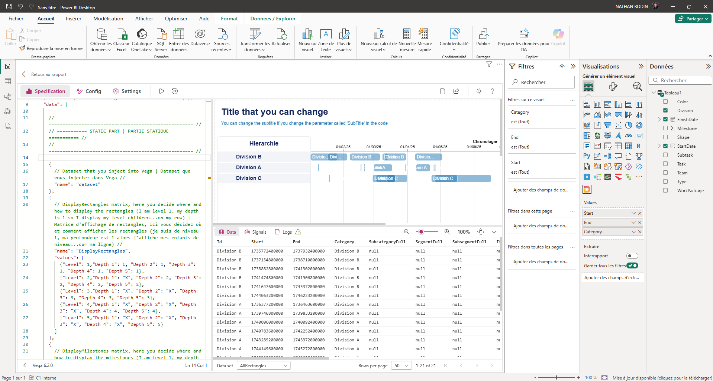

Here is the result if you only included the 3 required columns.

Hierarchy Columns (Required)
This visual is a hierarchical Gantt chart, meaning you must specify the desired hierarchy in the code. Here is the hierarchy:
Category > Subcategory > Segment > Subsegment > Item.
Be sure to follow this order.

Date columns (Required)
The Start and End columns are date columns that will be used to place the elements on the Gantt chart.

Milestones (Column "Milestone")
You can also choose to add Milestones (which you will rename to Milestone). A Milestone must be a column of 0 or 1 (1 meaning that this row is a Milestone).

The shape of the milestones (Column "Shape")
Next, using the "Shape" column, you can decide on the shape of each of these Milestones. Here are the possible shapes:
circle :
square :
cross :
diamond :
triangle-up :
triangle-down : …
triangle-left : …
triangle-right : …
wedge :
arrow :

You can also import your own shapes via an SVG path (you can build your shape and then retrieve the path here) : https://yqnn.github.io/svg-path-editor/). So you have an infinite number of possible forms.

The size of the milestones (column "ShapeSize")
If you want to adjust the size of the milestones to perhaps indicate different levels of importance for each milestone, you can do so by entering a number in this column.

By default, the milestone shapes have a size of 500.
This can also be useful if you have created your own milestone and it is not the same size as the default milestones. This column also allows you to assign two different sizes to two milestones that have the same shape.

Otherwise, if you haven't entered a ShapeSize column, then the solution will look in the "Shape" table in the code to see if the name of your milestone's shape corresponds to a size:
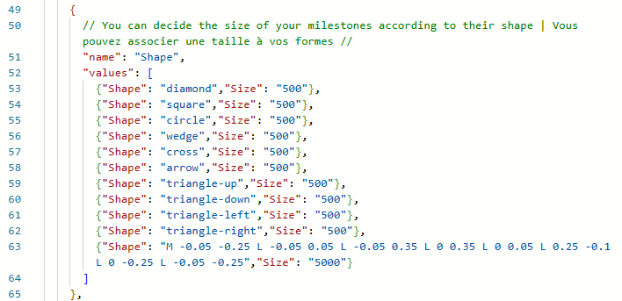

Here is the Shape table. You can add a row to this table at any time to add your shape and associate a size with it. Like the last row:

{"Shape": "M -0.05 -0.25 L -0.05 0.05 L -0.05 0.35 L 0 0.35 L 0 0.05 L 0.25 -0.1 L 0 -0.25 L -0.05 -0.25","Size": "5000"}
This is the SVG path for the flag. However, 500 (the default size) was too small for this shape, so I decided to set the size to 5000.
If this match doesn't exist in this table, then the default size of the marker in question will be 500.

Note that the solution will first look at your ShapeSize column; otherwise, it will look at the Shape table, and if that fails, it will use the default size (500).

The Legend (column "Legend")
The Legend column is used to ensure that rows with the same legend are color-coded.
This column can be used, for example, to visually differentiate between tasks that are in progress, overdue, or completed.

The color (column "Color")
If you want to use your own colors, you can enter them in the Color column (in hexadecimal or English).
Alternatively, if you don't have a Color column, you can specify a color for a Legend in the code.
To assign a color to a legend:
19
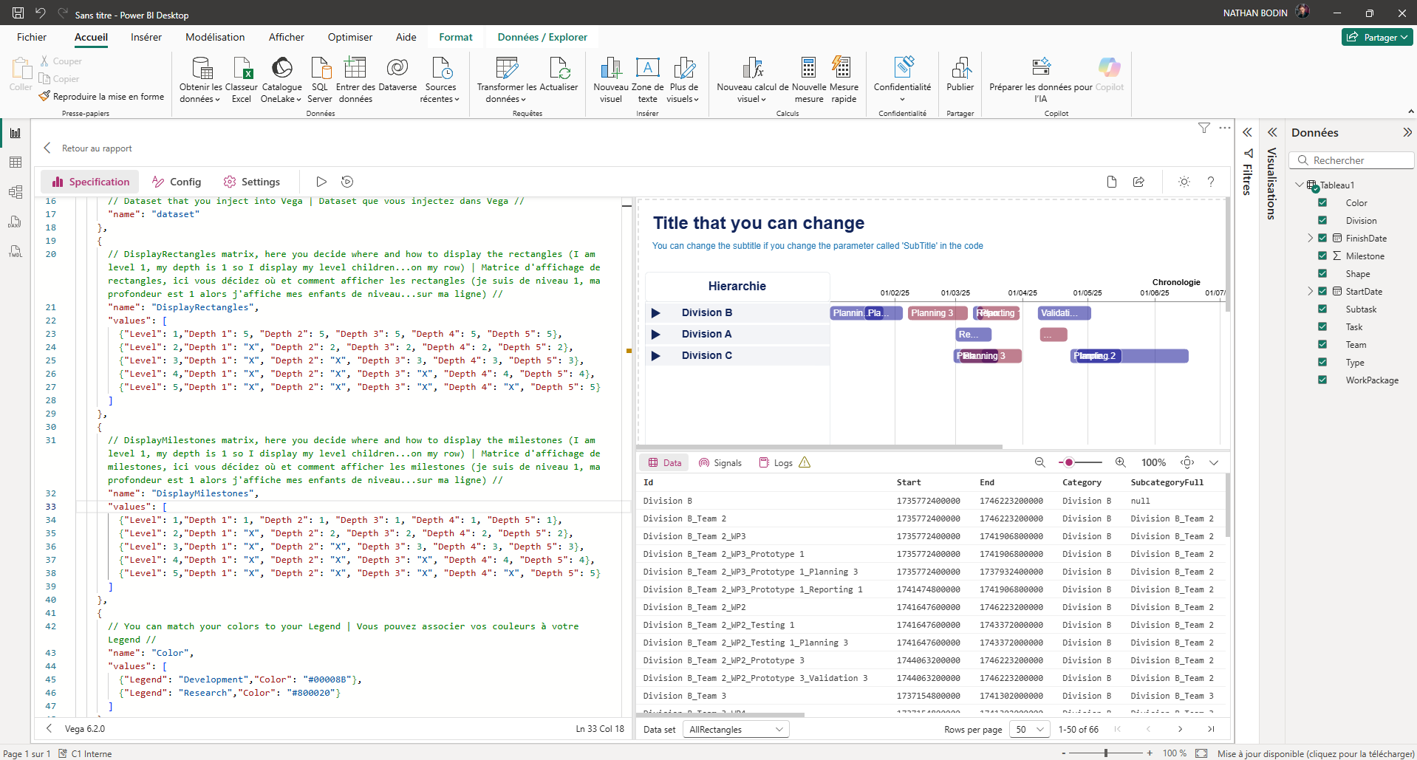
- Go to line 45 of the code. This is the table for associating a color with a Legend.
- You have those lines : {"Legend": "Development","Color": "#00008B"},
- Replace "Development" with the Legend of your choice and "#00008B" with the color of your choice.
- You can duplicate these lines to have multiple associations.
Note that if you have included a "Color" column, it will take priority; otherwise, the program will check if you have created any Legend-Color associations in the "Color" table. If not, the program will choose the colors itself. All rows with the same Legend will have the same color.

Note that colors are applied to the rectangles at the bottom of the hierarchy. You cannot control the color of parent rows using the color column or color table.

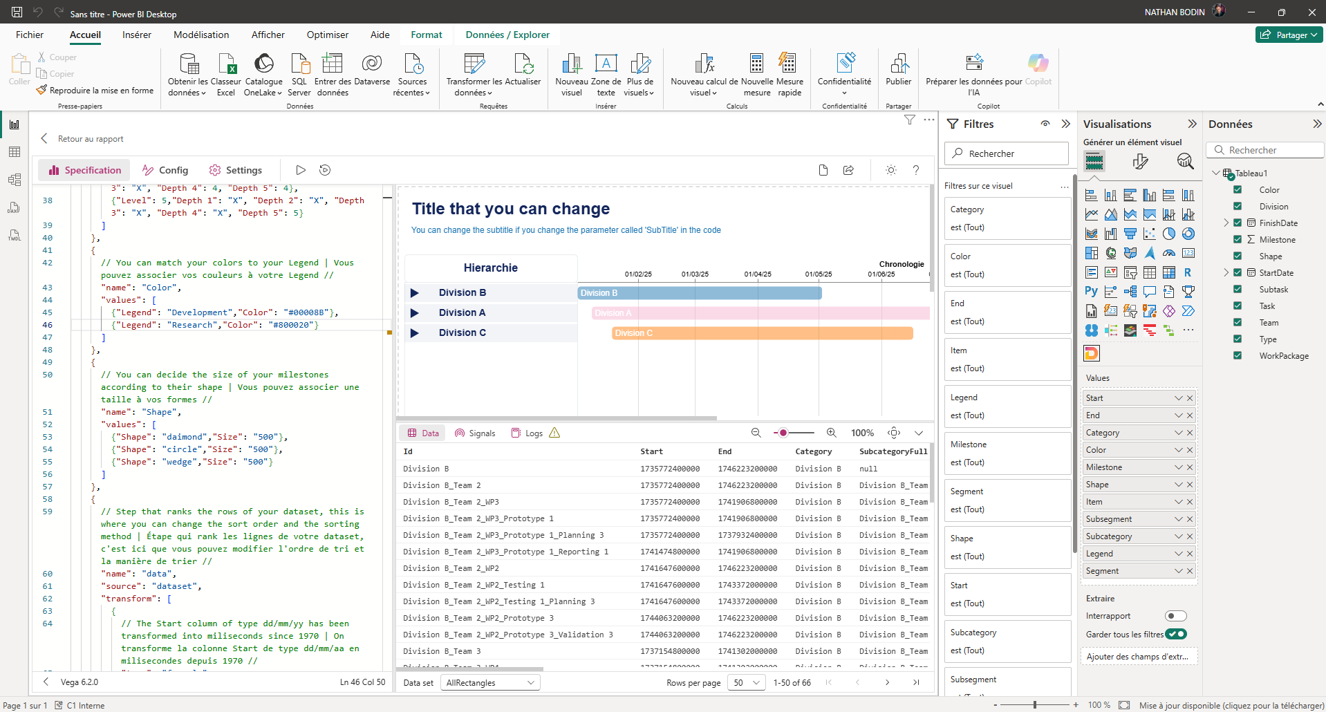

Here's the result if you've filled in all the columns. But it's not finished yet; to get the look you want, you need to configure it correctly.

The height of the rectangles (Column "Size")
This column can be used, for example, to represent the workload of agents for a mission (this agent is at 70% on this mission, so their rectangle will be 70% of the maximum height of a rectangle).
This column is a color of decimal numbers from 0 (0% of the maximum height) to 1 (100% of the maximum height of the rectangle).

Note that in this case I advise you to increase the maximum height of a rectangle in the system parameters of the code (which we will see a little later in the MODOP) because by default the size of the rectangles is too small for such a representation.

The labels in the rectangles (Column "Label")
By default, the solution will label the rectangle with its name (the one displayed in the hierarchy column to the left of the Gantt chart). However, if you want to add other information about the rectangles, simply add a Label column (containing the desired information for each rectangle).
This label will be placed at the lowest level of the hierarchy (similar to the color label).

This column can, for example, be used to indicate an agent's workload on a mission (showing the rectangle height and the precise occupancy rate directly on the rectangle).

Visual configuration

The matrix (Superposition/Swiss) of rectangles
Y-axis: row level (1 = Category → 5 = Item) X-axis: visible branch depth (1 = only the category is visible → 5 = all levels up to the items)
Value A at the Y/X intersection: determines which levels should be displayed on each row
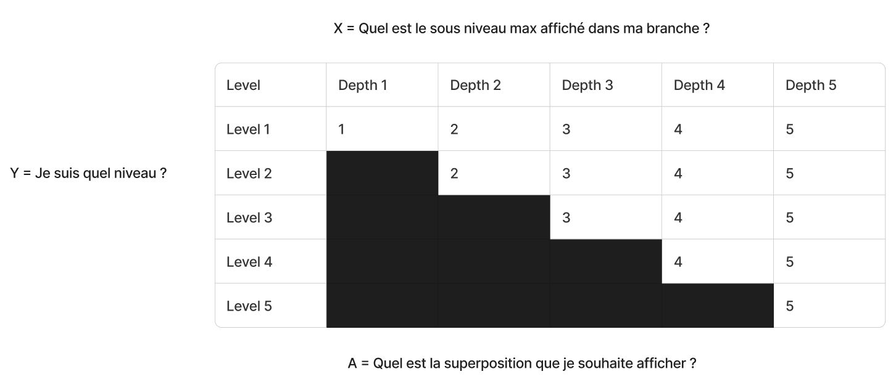

Example 1: Level 1 (Category), depth 1, A = 1 → display the Category itself:
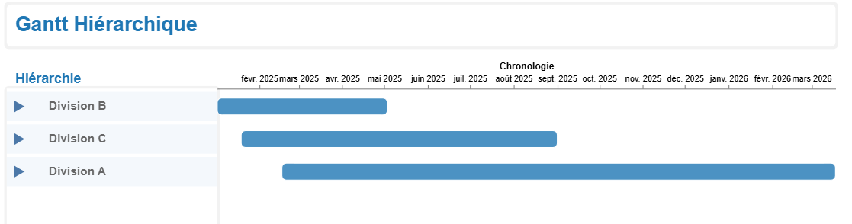

Example 2: Level 1 (Category), depth 2, A = 2 → display the level 2 children on the Category row
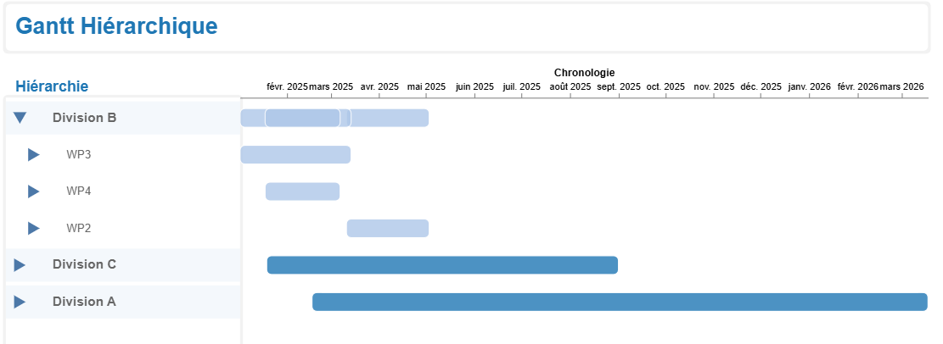
In this example 2, we can clearly see that Division B is equal to the overlap of the light blue rectangles below.

Note: In the matrix, you can enter a value A greater than the depth. This means that a parent element can display its descendants (of a level x) on top of itself, even if these descendants are not yet displayed in their respective rows.

Be careful, if you enter values ​​in the matrix greater than the number of levels you have (if you enter 5 when you only have 3 hierarchical levels), then nothing will be displayed.
17

- In "DisplayRectangles" (17) you can modify the values ​​of this matrix. For example, on the level 1 row, you can decide that regardless of the Gantt chart's development, level 5 children will move to the level 1 row by placing 5s throughout the row. Then run "run".

Setting up the Milestone Matrix
18
- In the "DisplayMilestones" table (18), you can modify the values ​​of this matrix. Its operation is similar to the previous matrix, but this matrix manages the behavior of the Milestones. Therefore, the Milestones are independent of the rectangles.

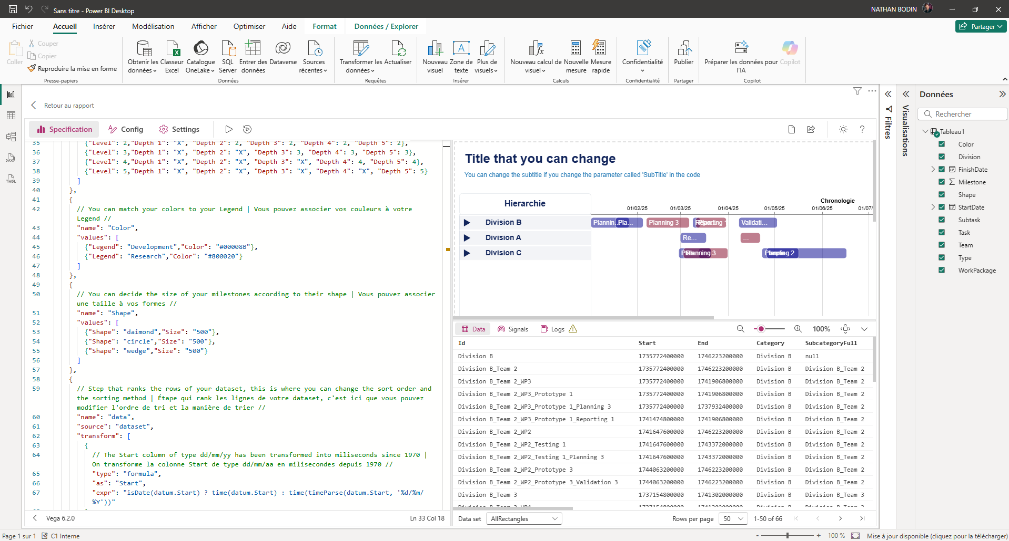
Setting the size of shapes
20

- In the "Shape" table (20) you can decide the size of each shape according to the nature of the shape. Otherwise, the default size is 500.

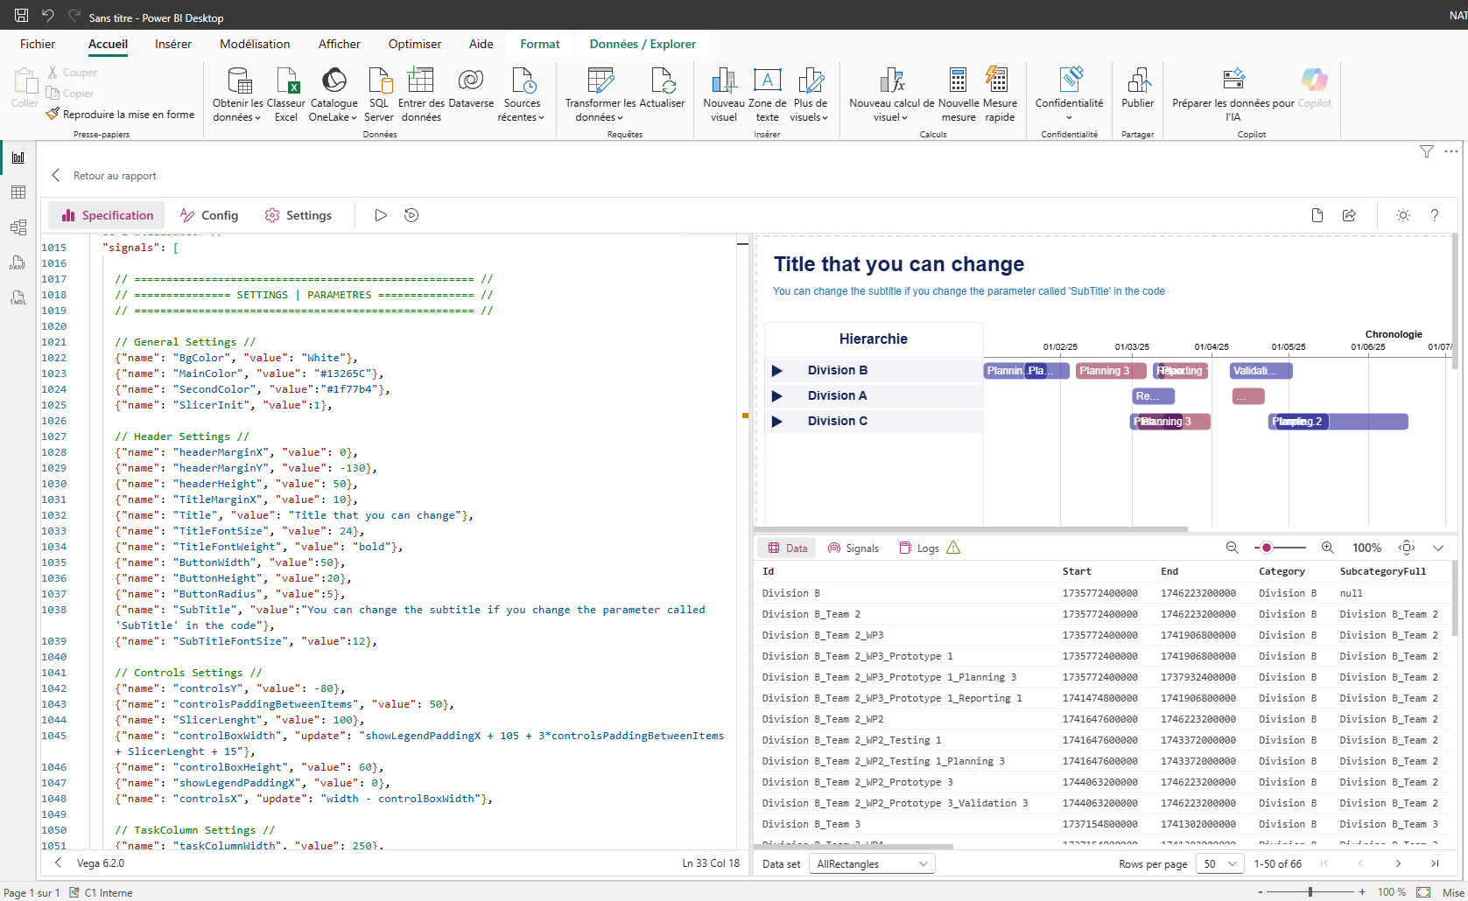
Visual settings
21

- You can modify pretty much anything you want. To do this, go to the code and scroll down to line 1150 where you will see "SETTINGS" (21). You can change any value of these parameters.
This settings area is divided into several parts. Each part manages a specific area of ​​the visualization. Here are these areas:
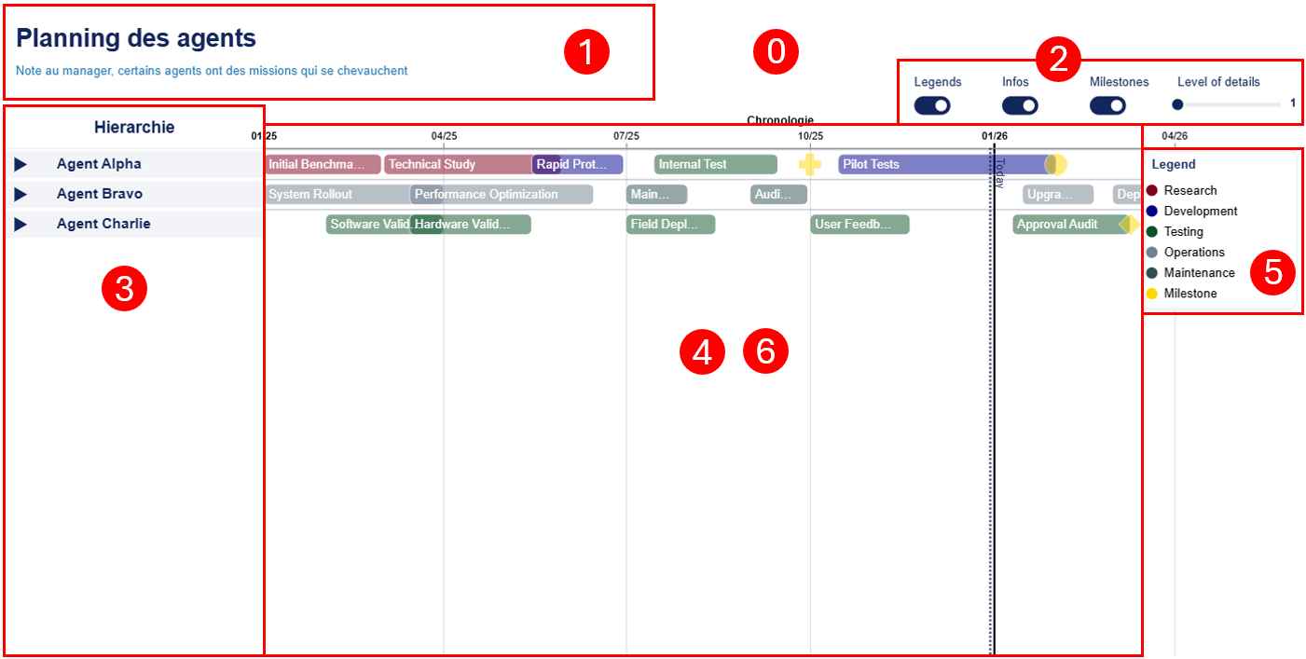

- « General Settings »
- « Header Settings »
- « Controls Settings »
- « TaskColumn Settings »
- « Gantt Settings » (excluding info bubbles)
- « Legend Settings »
- « Tooltip Settings » (or "Info bubbles" excluding Gantt)

Remerciements
I would like to thank:
- Arnaud GELLEZ for the help and support he gave me in the creation of this tool.
- Thibaud GUERET, Laetitia BARILLET, Christophe DURAND and Aurore CABRERA for their user feedback.
- Davide BACCI, whose work inspired me to create this tool.
- Madison GIAMMARIA whose work inspired me to create this tool.

